Suspend Debar Review in the Federal System

For any Purchase of goods and/or services greater than $3,499.99, a SAM Federal Report {otherwise known as SuspendDebarReview.pdf } is required. Since the Department uses Federal Funds, we are required to ensure suppliers are in good standing with the Federal Government through the SAM {System for Award Management} website. We cannot use any vendor who is suspended or debarred under the SAM system. Only those vendors who have NO Active Exclusion or return No Search Results as they are not found in their system are acceptable.

UPDATE 2/6/2019 from Purchasing:
When an E-Verify and SAMS report are required for a purchase order for Services greater than $3,499.99 please load both pages as ONE (1) FILE under the “ADD COMMENT” tab and NOT on the lines. (This tab will say “EDIT COMMENT” if there is more than one item loaded.)

Go to https://www.sam.gov/SAM/pages/public/searchRecords/search.jsf
Below is what it looks like….Click on Search Records, circled in red

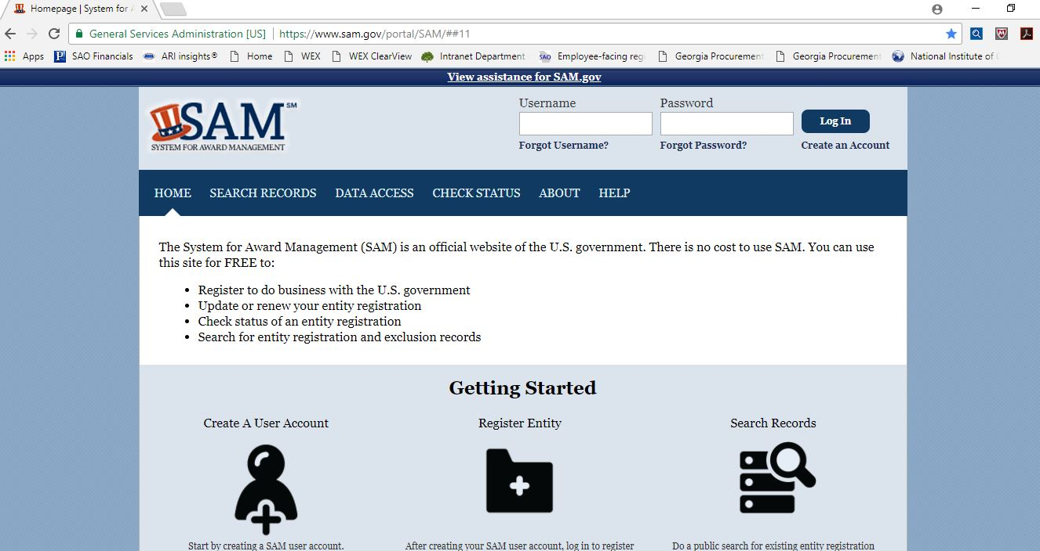
This pulls up….
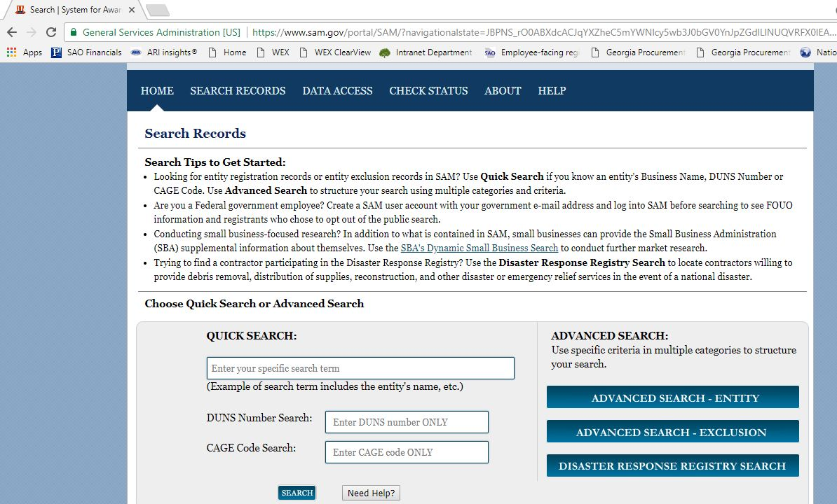
Enter the supplier’s name and then click Search…sometimes it is better to enter the main word in a supplier’s name….see red circles

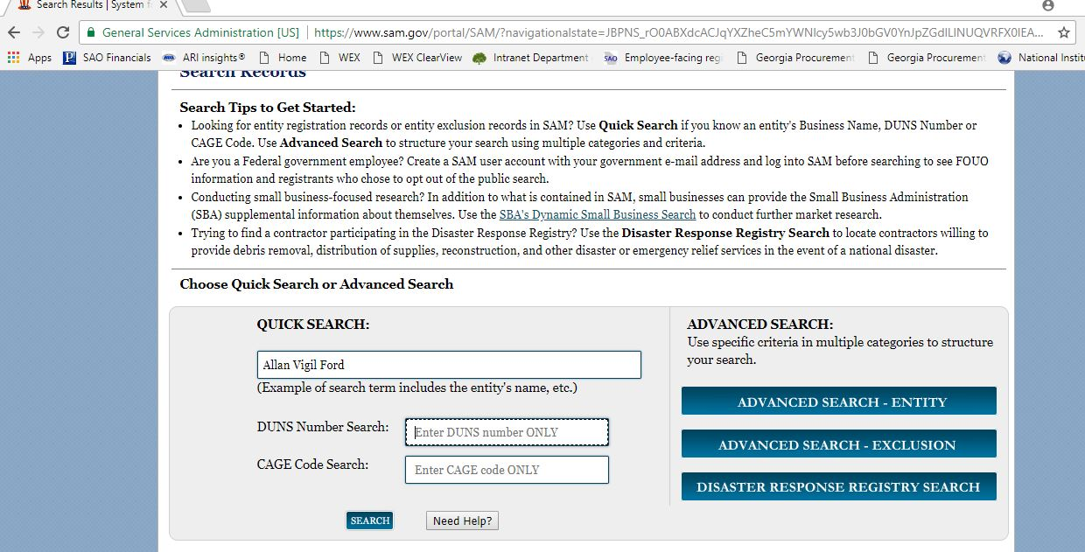
The below pulls up…..Click on Save PDF….see red circle
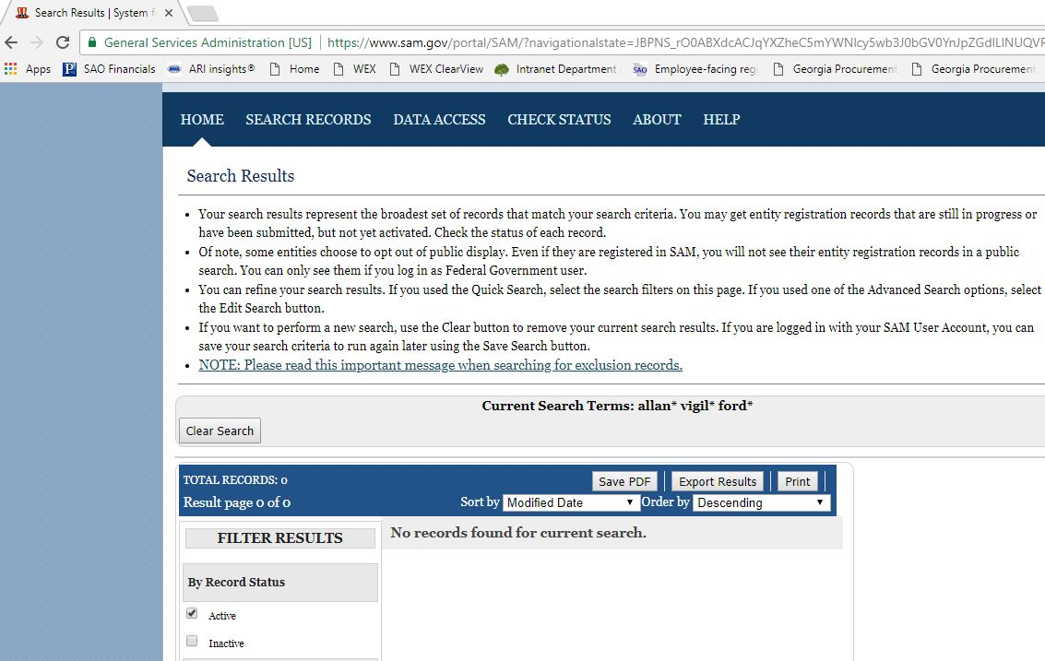
Save it as SuspendDebarReview.pdf to your hard drive and it will look like the attached SuspendDebarReview.pdf.

ANOTHER Example….
See above pic 1 and 2 and then Enter the Supplier Name and click search….see red circles
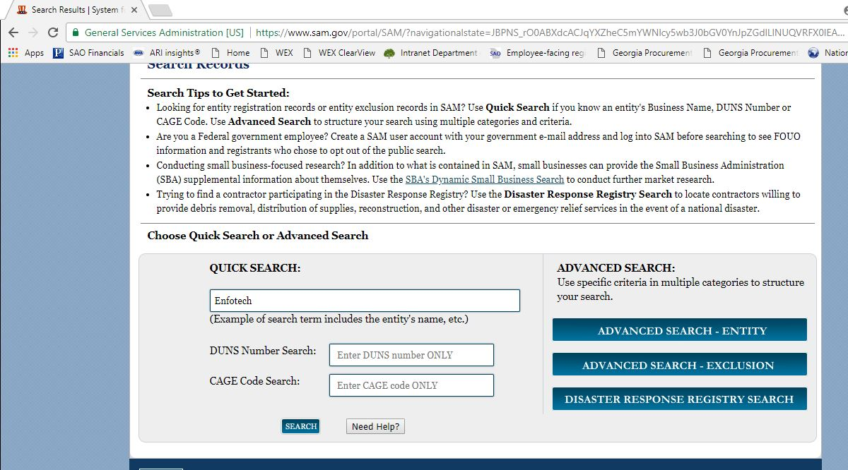
The following pulls up…This is what you will normally get. You are looking for NO by “Has Active Exclusion?”. Click on Save PDF and save to your hard drive….see red circles

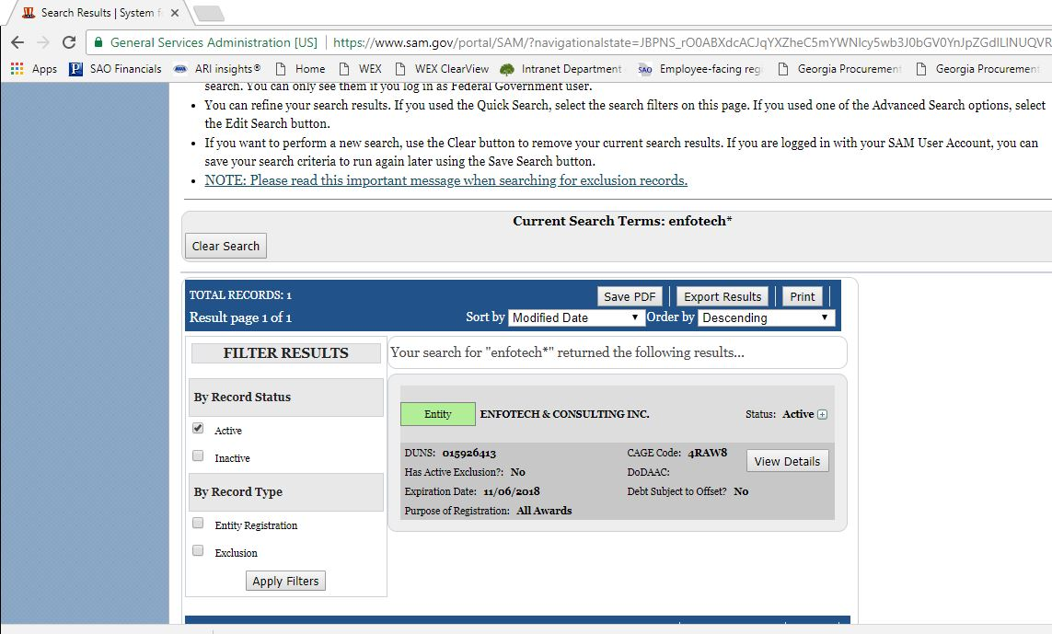
Sometimes there are many vendors that pull up, if so look at the correct vendor and save it.
GOOD REPORT EXAMPLES
No for Has Active Exclusion?
OR
No Search Results

Directions to upload the pdf to PeopleSoft Financials
Log in and pull up your PO in update mode.
Click on “Add Comments”
Click on the “Attach” button
Click on “Choose File”
Find your SuspendDebarReview.pdf and click on it
Click on “Open”
Click on “Upload”

